7th November 2016
East Riding of Yorkshire
Swinefleet Primary School
‘Fulfilling Potential, Rewarding Success’

Firstly, a big thank you to all of you who attended our Parents’ Evening. It was great to receive such positive comments and I will be uploading these to our school website very soon. If you were unable to attend please feel free to book an appointment with the class teacher either via them or the school office.
I enjoyed the coffee morning last week and it was useful to be able to speak to parents about what they thought was working well in school and future suggestions. It is a good opportunity to ask me questions and I have gone away with new ideas. Even little things can help to make our school better and in the toast letter sent out today little niggles that we as a school may not consider can have an impact on you as families so thank you to those parents who raised this. We hope to hold a coffee morning again soon with the Chair of Governors so that you can have the opportunity to speak to Mrs Cusick as well. If you have any questions, suggestions, positive comments or concerns please place them in the comments box which is now located in the main entrance. The school has changed its twitter account so please follow us @Swinefleet_Pr

Diamonds
There has been a lot of singing coming from the Diamonds’ classroom as they have been learning a song about skeletons and which bones are connected. I was impressed to see their own skeletons which they created out of cotton buds.
Miss Parkin has taught the children the story Funny Bones using Talk for Writing and they have then used this to create their own story maps.
Rubies (Reception and Year 1)
The Rubies have been making some jam sandwiches as part of their learning on instruction writing. I was very impressed with the lists they created which showed me what I would need to make a jam sandwich.
The writing especially in year 1 is really coming along with the Talk for Writing approach they are now using. It is wonderful to see the children reciting texts with their own actions.
Rubies (Nursery)
The Nursery Rubies have been learning about quieter and louder as part of their phonics. They have been looking at counting and finding certain numbers of objects.
I was very impressed with their artwork last week. For bonfire night, they have been practising writing their name with glitter as if they were doing this with a sparkler.

Sapphires
Sapphires have started their new topic looking at rivers and the local area. They have already learnt about the main features of a river and have begun to investigate rivers around the World.
Today the children have been playing games in English looking at how to use subordinating conjunctions.

DINNER MENU
Tues | Classic Lasagne  Selection of Bread  Winter Salad | Strawberry Mousse or  Fresh Fruit or  Yoghurt
Wed | Roast Pork Loin  Yorkshire Pudding  Creamed Potatoes  Broccoli & Carrots | Oaty Apple & Cinnamon Crumble or  Fresh Fruit or  Yoghurt
Thurs | Chicken Korma  Brown & White Rice  Naan Bread  Vegetable Medley | Melting Moment or  Fresh Fruit or  Yoghurt
Fri | Tempura Battered Fish  Steak Fries  Sweetcorn & Garden Peas | Pear & Chocolate Sponge or  Fresh Fruit or  Yoghurt
Mon 14th | Meatballs in Rustic Tomato Sauce  Pasta  Broccoli & Sweetcorn | Eves Pudding & Custard or  Fresh Fruit or  Yoghurt
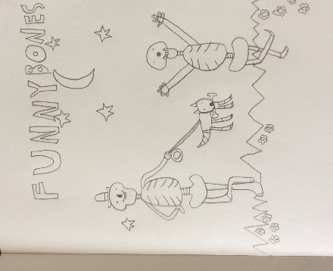
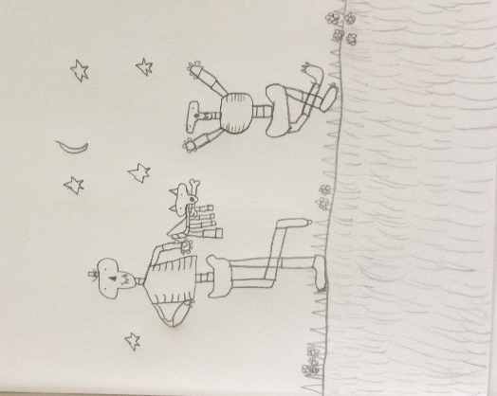
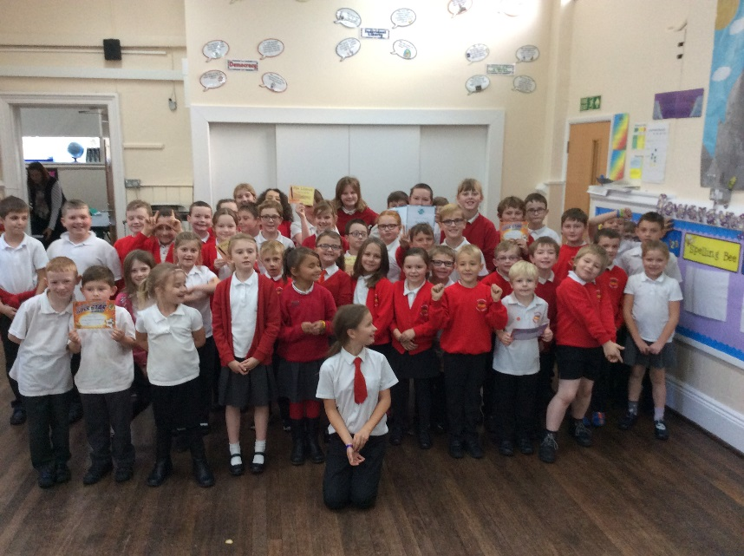
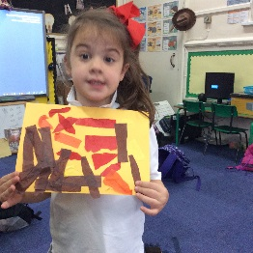
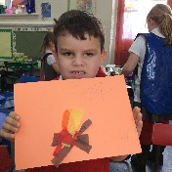
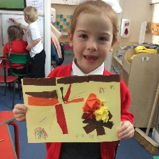
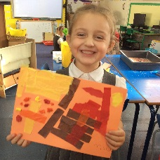
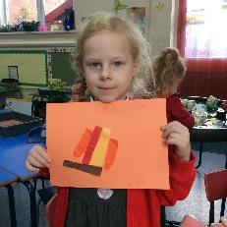
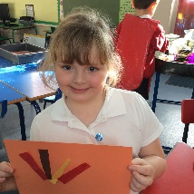
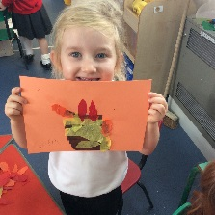
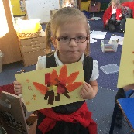
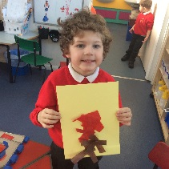
Example Funny Bones Art
Bonfire Artwork
Attendance
98%
Good
Well done to each class who got a roll on our attendance game.
Dates for your Diary
11th Nov – Remembrance Day at the monument at the edge of the village 11am. (Please feel free to join us).
14th Nov – Anti-bullying Presentation by Axholme Academy pupils.
14th Nov – Vicar assembly 3pm.
18th Nov – Children in Need organised by the school council (see separate letters).
21st Nov – Road Safety Assembly.
Cricket coaching each Fri morning for Sapphires and Diamonds.
House Teams
This week Ben Nevis achieved the most Swinefleet tokens.
Well done!
If you would like to share something with us please add a note to our comment box in the hall. We also welcome any suggestions as working together is what will continue to improve our school further.
Look at the Parents’ section of our website to see your views and what we are doing to address any worries.
Remember
Remember that children need P.E kit in school at all times.
Photograph orders to be in by the 11th November.
Assembly Champions

