24th November 2016
East Riding of Yorkshire
Swinefleet Primary School
‘Fulfilling Potential, Rewarding Success’

I would first of all like to thank all of you for making our Children In Need event such a success. I was amazed by the standard of the Bake Off entries and I was so pleased that I did not have to judge as I could never have picked. Well done to all of you and especially our prize winners who we will be arranging a meal out for very soon. Our Guess the Spots Competition was won by Logan who received £20! With only 68 pupils in the school I could not believe that we managed to raise £193. £100 was raised through our cake stall, £53 through non-uniform and £40 on Guess the Cake. Thank you all for digging deep and well done to our school council for arranging such a great event.
Remember on the 9th December it is our Christmas Fayre 2:30pm – 6pm. This is the perfect opportunity to buy your Christmas gifts and support the school. If you know anyone who would like a stall for £5 please contact the school office.
The school has changed its twitter account so please follow us @Swinefleet_Pr

Diamonds
Last week, Diamonds were learning all about Crime Scene Investigators. They could tell me all about the job and what they might look for.

The children have also been discussing and creating their own rules for the World. There were some very interesting ideas and many we base our school rules upon. Ideas included such things as: ‘Do not hurt people like by kicking them’ or even ‘Do not trump!’

Rubies
Last week, the Year 1 were busy doing some assessments to show us just how much they have been learning. I am very impressed with their determination and concentration at such a young age! Well done Year 1.
As you may have noticed we are making improvements to our outdoor area. The classroom is also beginning to transform and the children have enjoyed exploring their new environment.
All of the Rubies are now together in one classroom so that the outdoor area becomes more a part of the classroom and the other room can be used as a quiet zone for adult focus. We believe that this change will mean that the provision the children have access to will be of a higher quality and that there will be a vital quiet space to help aid concentration.

Sapphires
Sapphires had a hard week last week especially those in Year 6 as they have been looking at division. It was great to see the children striving towards a challenge. The Year 6 are particularly proud of themselves as they have cracked long division!
Mrs Kidd has been particularly pleased with the fantastic river legends that the children have been writing. Their creativity and use of their English skills has led to work that they should be proud of!

DINNER MENU
Mon 28th | Ham & Cheese Pizza  Potato Wedges  Baked Beans | Chocolate Crunch with Pink Custard or  Fresh Fruit or  Yoghurt
Tues  29th | Classic Lasagne  Selection of Bread  Winter Salad | Strawberry Mousse or  Fresh Fruit or  Yoghurt
Wed  30th | Roast Pork Loin  Yorkshire Pudding  Creamed Potatoes  Broccoli & Carrots | Oaty Apple & Cinnamon Crumble or  Fresh Fruit or  Yoghurt
Thurs  1st | Chicken Korma  Brown & White Rice  Naan Bread  Vegetable Medley | Melting Moment or  Fresh Fruit or  Yoghurt
Fri  2nd | Tempura Battered Fish  Steak Fries  Sweetcorn & Garden Peas | Pear & Chocolate Sponge or  Fresh Fruit or  Yoghurt
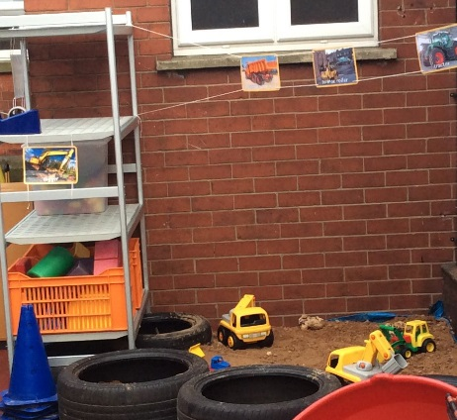
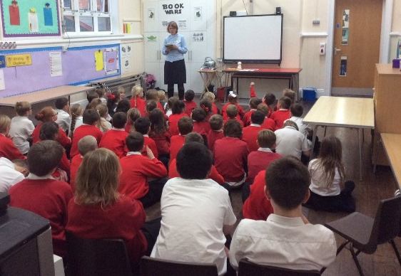
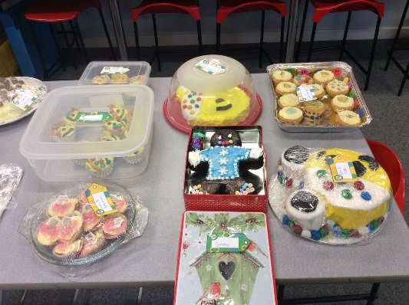
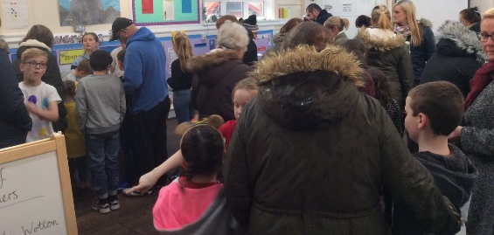
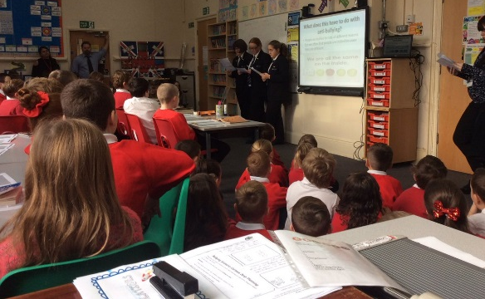
Assembly with the vicar
Anti-bullying Week with Axholme Academy students
Thank you for your generosity towards the Poppy Appeal. We have just found out that we raised an impressive £80.08p
Attendance
96%
Needs Improvement
Well done to Rubies and Diamonds who got a roll on our attendance game.
Dates for your Diary
Mon 5th Dec –Christmas Panto 1:30pm
Fri 9th Dec – Christmas Fayre 2:30 – 6pm
Tues 13th Dec – Christmas Dinner Day
Tues 13th Dec – Christingle at church (all welcome) 2:15pm
Wed 14th Dec – Christmas Party Afternoon at the village
hall.
Thurs 15th Dec – Nativity (10:30am and 2pm showings)
Fri 16th Dec – Christmas Jumper Day
Fri 16th Dec – Break up.
Well we should certainly be feeling festive after all of this!

House Teams
This week Snowdon achieved the most Swinefleet tokens.
Well done!
If you would like to share something with us please add a note to our comment box in the entrance. We also welcome any suggestions as working together is what will continue to improve our school further.
Look at the Parents’ section of our website to see your views and what we are doing to address any worries.
Remember
Remember that children need P.E kit in school at all times.
Christmas Fayre Friday 9th Dec in partnership with FOSPS
2:30 – 6pm

